Scenario 4: How to delete the elastic IP address.
Step 1: first the dissociate the Ip from the instance.
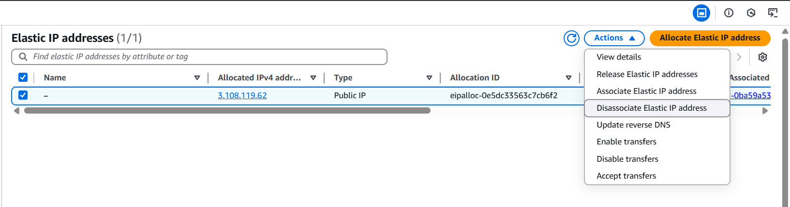
Step 2: once done, click on actions > select Release Elastic IP addresses
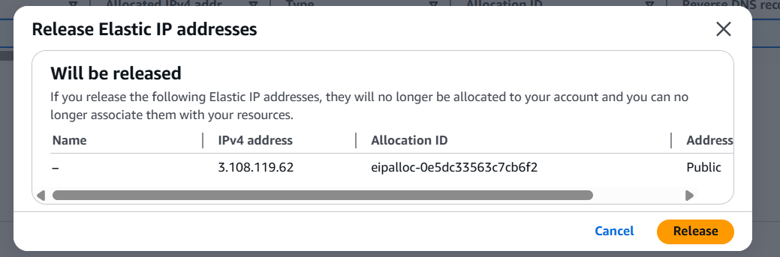
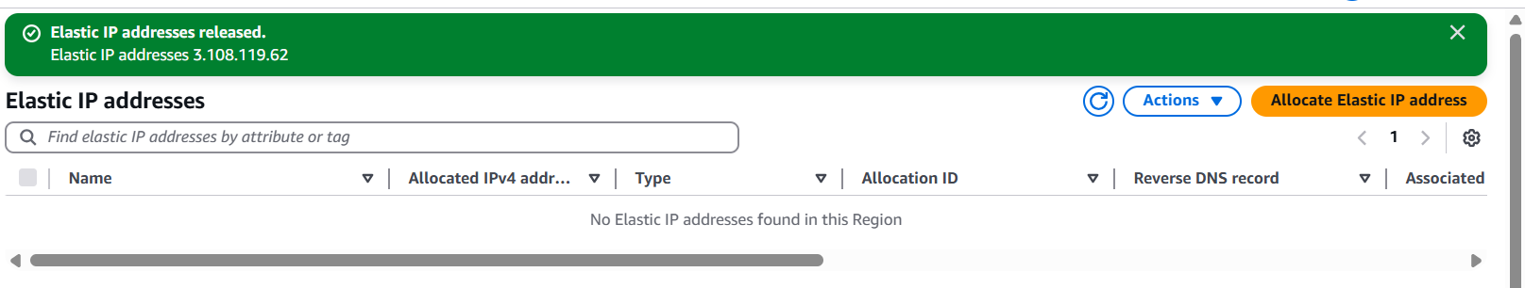
We have successfully released the elastic IP addresses.

